

**2023 – 2024**



# INTERNSHIP REPORT ON

**WEB DEVELOPMENT**

At

## TechnoHacks EduTech, Bengaluru

**Submitted to Bengaluru City University**

**In partial fulfillment for the award of BCA Degree**

**By**

**VI Sem BCA**

**Under the guidance of**

**Assistant Professor, Department of Computer Science**

**SJR College of Science, Arts and Commerce**

**#9, Race Course Road, Bengaluru – 560 009**



Techno Hacks Ed

u

Tech



An Internship Report



On

# “WEB DEVELOPMENT’’

Under the guidance of

**MR. Sandip Gavit**

**Technical Trainer and Guide**

TechnoHacks EduTech,



Bengaluru **College of Science, Arts and Commerce**

**Department of Computer Science Internship 2023 – 2024**

## EVALUATION OF INTERNSHIP REPORT

**For submission to Bengaluru City University**

|  |  |
| --- | --- |
| **Student** | **Mentor** |
| **Name:** | **Name:** |
| **UUCMS NO:** | **Signature:** |
| **Signature:** |
| **Date:** | **Date:** |

**Evaluation Summary**

|  |  |  |  |
| --- | --- | --- | --- |
|  | **Project** | **Viva – Voce** | **Total** |
| **Max. Marks** | **60** | **40** | **100** |
| **Marks Allotted** |  |  |  |
| **Name of the Examiner** | | **Signature:** |  |



## ORGANIZATION CERTIFICATE

This is to certify that student of VI semester BCA bearing UUCMS NO:

at SJR College of Science, Arts & Commerce, Bengaluru, has completed his 4

Weeks of organizational study on “**WEB DEVELOPMENT**” at our organization from **April 1st** to **April 30th, 2024**

**Sagar C** has collected the required data and exhibited good discipline and completed the assigned tasks as required during the period.

We wish him good luck in all future endeavors.

.

Place: **Bangalore For**: **TechnoHacks EduTech** Date: **April 30th 2024**

## Sri Jagadguru Renukacharya College of Science, Arts and

**Commerce**

### Department of Computer Science

**#9, Race Course Road, Bengaluru – 560 009**

### CERTIFICATE

This is to certify that this Internship report on “**WEB DEVELOPMENT**” is carried out by of VI semester BCA, bearing He has successfully completed his Internship at TechnoHacks EduTech Bengaluru.

The Internship report is submitted to the Bengaluru City University in the Academic Year 2023-24, in partial fulfillment for successful completion of VI Semester BCA and award of Bachelor of Computer Application Degree of Bengaluru City University.

**Place: BANGALORE PRINCIPAL Date:**

### SUPERVISOR'S CERTIFICATE

This is to certify that the content of this report on “**WEB DEVELOPMENT**” at

**TechnoHacks EduTech**carried out by student of VI semester BCA, bearing is a bonafide work carried out by the student under my supervision during the academic year 2023-24 in partial fulfillment for the completion of VI Semester BCA, of Bengaluru City University.

This Internship report is an original work carried out by the said student. This Internship report has not been submitted for the award of any other degree in this institution or any other institution.

**Place: BANGALORE Suja**

**Date: Assistant Professor**

### DECLARATION BY STUDENT

I hereby declare that this Internship report on **“**WEB DEVELOPMENT**”** using Web Developmenttools is an original record of my experience while conducting the internship study at **TechnoHacks EduTech, Bengaluru.**

The Internship study was carried out by me, in partial fulfillment for the successful completion of VI Semester of BCA of Bengaluru City University. This report is not submitted to any other university for the award of any Degree etc.

**Place: BANGALORE**

**Date:**

### ACKNOWLEDGEMENT

I am deeply indeed to **MR. Sandip Gavit Technical Trainer and Guide** for giving me an opportunity to carry out the Internship on “WEB DEVELOPMENT” at **TechnoHacks EduTech** and for giving vital support and guidance to complete this endeavor

I would like to express my gratitude to our for his constant support and encouragement.

I am extremely grateful to my Supervisor and Head, Department of Computer Science for his support and timely guidance provided for the completion and preparation of this report.

This endeavor would not have been possible without the support of my parents. My special thanks to them.

I would also like to thank my friends for their encouragement and moral support throughout the work.

**Index**

|  |  |  |
| --- | --- | --- |
| **SL. NO.** | **CHAPTER** | **NO. OF PAGES** |
| 1 | Company profile | 1 |
| 2 | Introduction to Technologies | 3 |
| 3 | Introduction to Project | 6 |
| 4 | Key Features in the project with brief explanation | 7 |
| 5 | Front-end Development design | 9 |
| 6 | Back-end Development design | 15 |
| 7 | Requirement Specifications | 17 |
| 8 | Project Use Cases and Use Case Diagram | 21 |
| 9 | Codes with documentation | 25 |
| 10 | Photo Gallery/screen shots | 33 |
| 11 | Conclusion | 35 |
| 12 | References | 36 |
| 13 | Offer letter | 37 |
| 14 | Completion letter | 38 |
| 15 | Log Index (Day-to-day activities) | 40 |

### COMPANY PROFILE

TechnoHacks EduTech is a cutting-edge software development company based in Nashik, Maharashtra. Established in 2022, our company has quickly gained recognition for our innovative solutions and commitment to excellence in the field of technology with a team of 10-50 dedicated professionals, we specialize in providing a wide range of services including web development, application development, corporate training, and digital marketing solutions.

Our mission is to empower businesses of all sizes by leveraging the latest technologies to enhance their online presence and streamline their operations. At TechnoHacks EduTech, we take pride in our ability to deliver customized solutions that meet the unique needs and objectives of each client. Whether it's creating a dynamic website, developing a user-friendly mobile app, or implementing a comprehensive digital marketing strategy, our team is dedicated to delivering results that exceed expectations.

As a company, we are driven by our core values of integrity, excellence, and collaboration. We believe in building strong, long-lasting relationships with our clients and partners, and we are committed to exceeding their expectations every step of the way.

At TechnoHacks EduTech, we are passionate about technology and dedicated to helping businesses thrive in the digital age. We look forward to the opportunity to work with you and help you achieve your goals.

**Website**: [www.technoahacks.co.in](http://www.technoahacks.co.in/)

**Industry**: IT services & Corporate Training

### ABSTRACT

This report presents an in-depth analysis of a web development program coupled with an internship experience aimed at equipping participants with practical skills and knowledge in the field of web development. The training module encompassed various aspects of modern web development, including frontend and backend technologies, responsive design principles, database management, and version control systems. Additionally, the internship component provided hands-on experience working on real-world projects under the guidance of experienced mentors.

The report begins by outlining the objectives of the internship program, highlighting the significance of bridging the gap between theoretical knowledge and practical application in the rapidly evolving landscape of web development. It then delves into the curriculum structure, detailing the topics covered, teaching methodologies employed, and the tools and technologies utilized throughout the training period.

Furthermore, the report evaluates the effectiveness of the training program in meeting its objectives, assessing the participants' proficiency in various web development skills before and after the training. It also examines the impact of the internship experience on enhancing the participants' practical capabilities, problem-solving skills, and teamwork dynamics.

Additionally, the report presents insights and reflections from both trainers and participants, providing valuable perspectives on the strengths and weaknesses of the program and recommendations for future improvements. It emphasizes the importance of ongoing learning and skill enhancement in the dynamic field of web development and underscores the significance of experiential learning opportunities, such as internships, in shaping competent and proficient professionals.

### INTRODUCTION

As a part-time remote intern at TechnoHacks EduTech, I was provided an opportunity to undertake a remote internship in Web Development The degree toward which I am currently studying is a Bachelor of Engineering in Computer Science and Technology. This was very beneficial for me, as at the end I could compare what I'd learned with what I already knew and find a connection between the two. This report is a description of my 6-week internship, carried out as a compulsory component of the training and internship at TechnoHacks EduTech. The following chapter describes the tools and technology used and provides an overview. Afterwards, I explain my role and tasks as a trainee and give specific technical details about my main tasks.

A career as a Web Developer can flex your adaptability and problem-solving skills. As a field that is constantly evolving to incorporate new technology, front-end development can reward those who like to learn new things and face challenges. The demand and flexibility of this position mean that there are many career opportunities available across various industries and locations. Whether that means working with a non-profit organization, starting your own freelance business, or being an in-house Web Developer for a company, you’ll likely have the chance to find a role that fits your interests. Because the job is computer-intensive, there are numerous opportunities to work remotely. Being a Web Developer can mean being able to work for companies across the country or even the globe from the comfort of your home. It rewards those who like to learn new things and face challenges.

### OBJECTIVES

Internships are generally thought of as being reserved for college students looking to gain experience in a particular field. However, a wide array of people can benefit from internships in order to receive real-world experience and develop their skills.

* An objective for this position should emphasize the skills you already possess in the area and your interest in learning more.
* Internships are utilized in a number of different career fields, including architecture, engineering, healthcare, economics, advertising and many more.
* Some internships are used to allow individuals to perform scientific research while others are specifically designed to allow people to gain first-hand experience working.
* Utilizing internships is a great way to build your resume and develop skills that can be emphasized in your resume for future jobs. When you are applying for a Training Internship, make sure to highlight any special skills or talents that can make you stand apart from the rest of the applicants so that you have an improved chance of landing the position.

#### TOOLS AND TECHNOLOGIES

1. **HTML:** HTML stands for **“Hyper Text Markup Language”**. HTML is the standard Markup language for creating Web pages. HTML describes the structure of a Web page. HTML consists of a series of elements. HTML elements tell the browser how to display the content.
2. **CSS:** CSS is the acronym of **“Cascading Style Sheets”**. CSS is a computer language for laying out and structuring web pages (HTML or XML). This language contains coding elements and is composed of these ―cascading style sheets‖ which are equally called CSS files
3. **JAVASCRIPT:** JavaScript is a scripting language for creating dynamic web page content. It creates elements for improving site visitors' interaction with web pages, such as dropdown menus, animated graphics, and dynamic background colors.
4. **BOOTSTRAP:** Bootstrap is a free, open sour[ce front-end](https://www.techtarget.com/whatis/definition/front-end) development framework for the creation of websites and web apps. Designed to enable responsive development of mobile-first websites, Bootstrap provides a collection of syntax for template designs.
5. **Git/GitHub:** Version control system for managing project files and collaboration.

#### INTRODUCTION TO PROJECT

**Project Title: Web Development (Web Application Frontend)**

A web developer is at heart an **interactive artist**. They’re someone driven by a **deep desire to create things**. A web developer’s canvas is a user’s web browser.

Much like how a curious child takes pleasure in making toys by joining LEGO blocks—and then experiences a similar joy in taking things apart to see how they’re made, a web developer’s job is to use the basic building blocks of the web (like HTML, CSS and JavaScript) to create something complex like a webpage. Don’t sweat it! We’ll get into all of those terms soon.

It's also the web developer’s job to diagnose problems in a website’s functionality, to understand how something works by reading the code behind it, and to make changes to fix any issues. That essentially makes web developers the physicians of the world wide web. When we talk about the world wide web, we’re mainly referring to websites and web applications. At this point, the curious aspiring developer in you might be wondering, ―What’s the difference between the two? ‖

Well, we’re glad you asked! A **website** is usually a simple page or a group of pages. However, modern websites are much more than that. Take Google[.](https://doc.new/) It has a nice interface that, once opened, looks very much like a desktop software like Microsoft Office. Such complex websites are often termed **web applications**. A web developer today is expected to know how to create and work with web applications. Having said that, most people use the terms interchangeably, so don’t get too hung up on the terminology!

An Web Development project involves replicating the functionality and design of the popular ecommerce platform Amazon. The project aims to create a web application that mimics key features of Amazon's website to provide users with a familiar shopping experience.

Key aspects of a Web Development project introduction may include:

1. **Objective**: The main goal of the project is to develop a functional e-commerce website that resembles Amazon, allowing users to browse products, add items to their cart, make purchases, and manage their accounts.
2. **Features**: Highlighting the core features that the Web Development will offer, such as product listings, search functionality, shopping cart management, checkout process, user accounts, and responsive design.
3. **Technologies**: Mentioning the technologies and tools that will be used to build the Web Development, including front-end frameworks (e.g., React, Vue.js), back-end technologies (e.g., Node.js, Django).
4. **Scope**: Outlining the scope of the project, including the number of product categories, user authentication methods, payment gateways, and any additional features to be implemented.
5. **Challenges**: Discussing potential challenges that may arise during the development process, such as integrating third-party APIs for product data, ensuring secure payment transactions, and optimizing the user interface for various devices.
6. **Benefits**: Explaining the benefits of creating an Web Development, such as gaining practical experience in building complex web applications, honing e-commerce development skills, and potentially showcasing the project in a portfolio.

#### KEY FEATURES IN THE PROJECT

Creating an Web Development frontend involves building the user interface of a web application that mimics the look and feel of the Amazon website. This frontend portion of the clone is responsible for how users interact with the site, browse products, add items to their cart, and complete purchases.

Key components of an Web Development frontend may include:

1. **Homepage**: A landing page that showcases featured products, deals, and categories to entice users to explore further.
2. **Product Listings**: Displaying products in a grid or list format, with images, descriptions, prices, and ratings visible at a glance. Users can click on a product to view more details.
3. **Product Details Page**: Presenting detailed information about a specific product, including multiple images, descriptions, specifications, customer reviews, and related products or recommendations.
4. **Search and Filter**: Allowing users to search for products using keywords and apply filters (e.g., price range, category, brand) to narrow down their choices.
5. **Shopping Cart**: Enabling users to add items to their cart, view a summary of selected products, adjust quantities, and proceed to checkout.
6. **Checkout Process**: Guiding users through the steps of entering shipping details, choosing a payment method, and confirming the order.
7. **User Account**: Providing functionality for users to create accounts, log in, manage their profile information, view order history, and save payment preferences.
8. **Responsive Design**: Ensuring the website is optimized for various devices (desktop, tablet, mobile) by adapting the layout and content to different screen sizes.
9. **Integration with APIs**: Connecting to backend services or third-party APIs to fetch product data, process user authentication, handle payments, and retrieve other information as needed.

#### FRONT-END DEVELOPMENT DESIGN

Web development is the process of creating websites or web applications that are accessible via the internet or an intranet. It encompasses a range of tasks, including web design, web content development, client-side scripting, server-side scripting, and network security configuration.

1.1.1. **Frontend Development:**

Frontend development focuses on the user interface and user experience of a website or web application. It involves creating the visual layout, design, and interactive elements that users interact with in their web browsers. Technologies commonly used in frontend development include HTML, CSS, and JavaScript.

HTML, which stands for Hypertext Mark-up Language, is the standard mark-up language used to create and design web pages. It defines the structure and layout of a webpage by using a system of tags and attributes to organize and present content. Here's a brief overview of HTML:

**Elements:** HTML documents consist of elements, which are defined by tags enclosed in angle brackets. Tags typically come in pairs: an opening tag and a closing tag, with content between them. For example:

<p>This is a paragraph. </p>

In this example, <p> is the opening tag, and </p> is the closing tag, indicating the start and end of the paragraph element.

**Attributes:** HTML elements can also have attributes, which provide additional information about the element. Attributes are specified within the opening tag and consist of a name and a value. For example:

<a href="https://www.example.com">Click here</a>

In this <a> element, href is the attribute name, and "https://www.example.com" is the attribute value, specifying the URL to link to.

**Document Structure:** HTML documents have a hierarchical structure, consisting of nested elements organized in a tree-like fashion. The top-level element is the <html> element, which contains the entire document. Within the <html> element, there are two main sections: the <head> section, which contains metadata and document information, and the <body> section, which contains the main content of the webpage.

**Common Elements:** HTML provides a wide range of elements for structuring content, including headings <h1> to <h6>, paragraphs <p>, lists <ul>, <ol>, and <li>, links <a>, images <img>, tables <table>, forms <form>, and more.

**Attributes:** Elements can also have various attributes that modify their behaviour or appearance. For example, the href attribute in <a> elements specify the URL that the link points to, and the src attribute in <img> elements specify the source URL of the image.

HTML is the backbone of web development, providing the foundation for creating and designing web pages that are accessible and user-friendly. It works in conjunction with other technologies like CSS (Cascading Style Sheets) and JavaScript to create dynamic and interactive web experiences.

**HEDAINGS**

HTML headings are defined with the <h1> to <h6> tags with H1 being highest (or most important) level and H6 the least:

<h1> Heading level 1</h1>

<h2> Heading level 2</h2>

<h3> Heading level 3</h3>

<h4> Heading level 4</h4>

<h5> Heading level 5</h5>

<h6> Heading level 6</h6>

The effects are:

**Heading Level 1**

**Heading Level 2**

**Heading Level 3**

**Heading Level 4**

**Heading Level 5**

**Heading Level 6**

**Cascading Style Sheets**

IT is a stylesheet language used to control the presentation and layout of HTML documents. CSS defines how HTML elements are displayed on a webpage, including their appearance, positioning, size, color, and typography. Here’s an overview of CSS:

**Example:**

<div id="box">

<p>Content</p>

</div> #box {

} width: 100x; height:100x; padding:10p x; margin: 10px; border: 1px solid black; **Selectors:** CSS uses selectors to target HTML elements and apply styles to them. Selectors can target elements based on their tag name, class, ID, attributes, or their relationship to other elements.

For example:

**Properties and Values:** CSS properties define the visual aspects of HTML elements, such as their color, font size, margin, padding, and border. Each property has one or more values that determine how the property should be applied. For example:

**Cascade:** CSS stands for Cascading Style Sheets, which refers to the mechanism of applying styles to elements based on their specificity and the order in which styles are declared. Styles can be inherited from parent elements or overridden by more specific selectors.

External, Internal, and Inline Styles: CSS can be applied to HTML documents in three ways:

**External Stylesheet:** CSS rules are defined in an external .CSS file and linked to the HTML document using the <link> element.

**Internal Stylesheet:** CSS rules are defined within the <style> element in the HTML document's <head> section.

**Inline Styles:** CSS styles are applied directly to individual HTML elements using the style attribute.

**Bootstrap:**

Bootstrap is a popular front-end framework for building responsive and mobile-first websites and web applications. Developed by Twitter, Bootstrap provides a set of pre-designed HTML, CSS, and JavaScript components and utilities that developers can use to create consistent, visually appealing, and functional user interfaces.

**Grid System:** Bootstrap includes a responsive grid system based on a 12-column layout. This grid system allows developers to create flexible and responsive layouts that adapt to different screen sizes and devices. Developers can easily create grid-based layouts by using Bootstrap's predefined grid classes, such as. container, row, and.coloum.

**JavaScript:**

JavaScript is a versatile programming language that is primarily used for creating dynamic and interactive content on websites. It was developed by Brendan Eich in 1995 and has since become one of the most widely used programming languages in web development.

var x;console.log(x); // undefined console.log (type of y); object

console.log(x===y);// false console.log(x==y);// true

**BOOTSTRAP**

A popular, open-source framework for developing responsive and mobile-first websites, Bootstrap offers CSS-based and JavaScript-based templates that include components like navigation bars, progress bars, thumbnails, and dropdowns, all of which you can incorporate into web pages.

Bootstrap is the most popular HTML, CSS and JavaScript framework for developing a responsive and mobile friendly website.

It is absolutely free to download and use..

It is a front-end framework used for easier and faster web development. oIt includes HTML and CSS based design templates for typography, forms, buttons, tables, navigation, modals, image carousels and many others.

It can also use JavaScript plug-ins , It facilitates you to create responsive designs

Bootstrap implements responsive images through built-in code that automatically resizes them according to the current screen size. Also, with the jQuery plugins in Bootstrap, you can build and deliver interactive solutions for modal pop ups, image carousels, and transitions.



**Key Features:**

**Client-Side Scripting:** JavaScript is executed on the client-side (i.e., in the user's web browser), allowing developers to create interactive user interfaces and respond to user actions in real-time without needing to communicate with the server.

**High-Level Language:** JavaScript is a high-level, interpreted programming language, meaning that it is easy to read and write, and does not require compilation before execution.

**Dynamic Typing:** JavaScript is dynamically typed, which means that variable types are determined at runtime. This flexibility allows for more expressive and concise code but can also lead to errors if not used carefully.

**Event-Driven Programming:** JavaScript is event-driven, meaning that it can respond to various events such as mouse clicks, keyboard inputs, and page loads. Developers can attach event handlers to HTML elements to execute JavaScript code in response to these events.

#### BACK-END DEVELOPMENT DESGIN

Backend development involves building the server-side infrastructure and logic that powers a website or web application. This includes handling database operations, processing user requests, and generating dynamic content. Popular backend technologies include server-side scripting languages like Python, PHP, and Node.js, as well as database management systems like MySQL and MongoDB.

Scheduled Tasks: Use Django's built-in task scheduler or external tools like Celery to schedule periodic crawls. Set up scheduled tasks to run at regular intervals to fetch and process new data from target websites.

**Data Processing:**

Implement logic to process and clean the crawled data before storing it in the database. This may involve text preprocessing, data normalization, or any other data manipulation tasks required for your specific use case.

**Logging and Monitoring:**

Implement logging and monitoring functionalities to track the crawling process, record errors, and monitor system performance. Use Django's logging framework or external monitoring tools to keep track of the backend operations.

**Security Considerations:**

Ensure that your web crawler adheres to ethical and legal guidelines when crawling websites. Respect robots.txt files, follow website terms of service, and implement rate limiting to avoid overloading target servers.

**Testing and Optimization:**

. Test your backend components thoroughly to ensure they function correctly under various scenarios. Optimize your code and database queries for performance to minimize response times and resource usage

By leveraging these tools and techniques within the Django framework, you can build a robust and efficient backend for your web crawler project. Database: A database is an organized collection of structured information, or data, typically stored electronically in a computer system. A database is usually controlled by a database management system (DBMS).

#### REQUIREMENT SPECIFICATIONS

**Hardware Requirements:**

**Processor (CPU):**

A multi-core processor with sufficient processing power is recommended, especially if you plan to run multiple crawling tasks concurrently or process large amounts of data, such as an Intel Core i3 or above, or an AMD Ryzen 3 or above.

**Memory (RAM):**

The amount of RAM required will depend on the size of the datasets being processed and the complexity of the crawling tasks. At least 4GB or higher of RAM is recommended, but more may be needed for larger projects.

**Storage (HDD):**

Sufficient storage space is needed to store crawled data, especially if you plan to crawl a large number of websites or store large media files such as images or videos. Consider using SSDs for faster read/write speeds, especially if you're dealing with large volumes of data. Additionally, ensure you have at least 256GB of storage to run HTML, CSS, JS, and Django applications efficiently.

**Network Connectivity:**

A stable internet connection is essential for fetching web pages and accessing external resources during the crawling process. Ensure that your network connection is reliable and has sufficient bandwidth to handle the data transfer requirements of your project.

**Software Requirements:**

**Operating System:**

Web crawler projects can be developed and deployed on various operating systems, including Linux (Ubuntu 18.04 or later), macOS (10.14 Mojave or later), and Windows (Windows 10 or later). Choose an operating system that you are comfortable with and that meets your deployment requirements.

**Web Crawling Libraries:**

Depending on your specific crawling requirements, you may need to install additional libraries like Beautiful Soup or Scrapy for web scraping and crawling tasks. These libraries provide functionality for fetching web pages, parsing HTML content, and extracting data.

**Development Tools:**

Use a text editor or integrated development environment (IDE) for writing code and managing your Front-End project files. Popular options include Visual Studio Code, PyCharm, Sublime Text, and Atom.

**Version Control:**

Use version control software like Git to track changes to your project code and collaborate with other developers. Host your code repositories on platforms like GitHub, GitLab, or Bitbucket for easy collaboration and version management.

**SCREEN SHORTS**

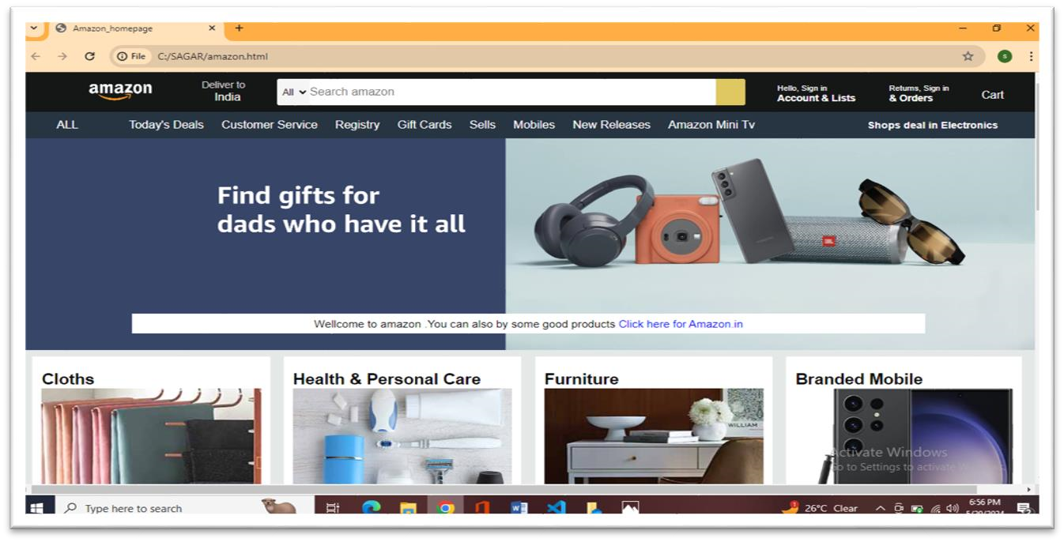

**User-Interface**

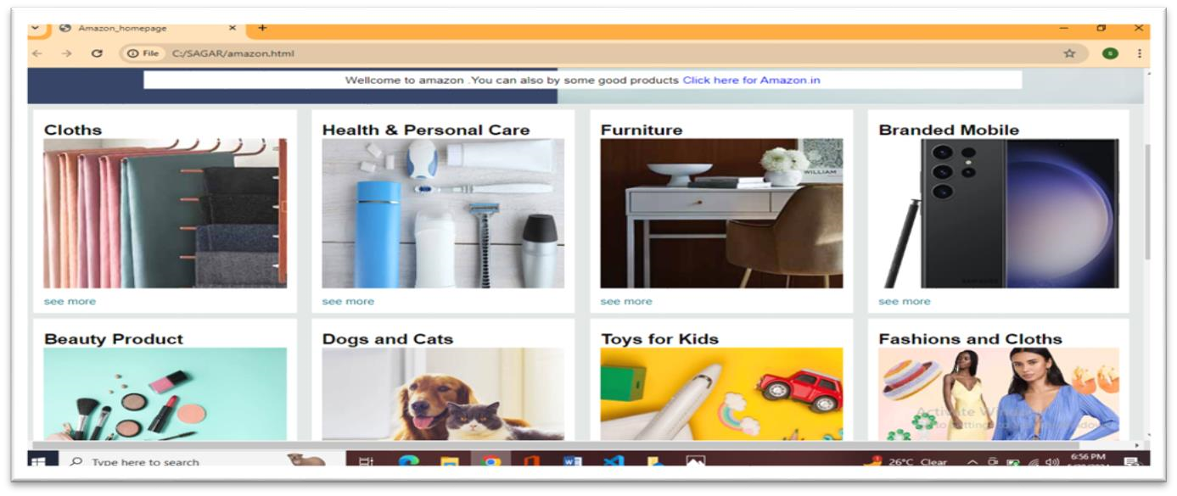

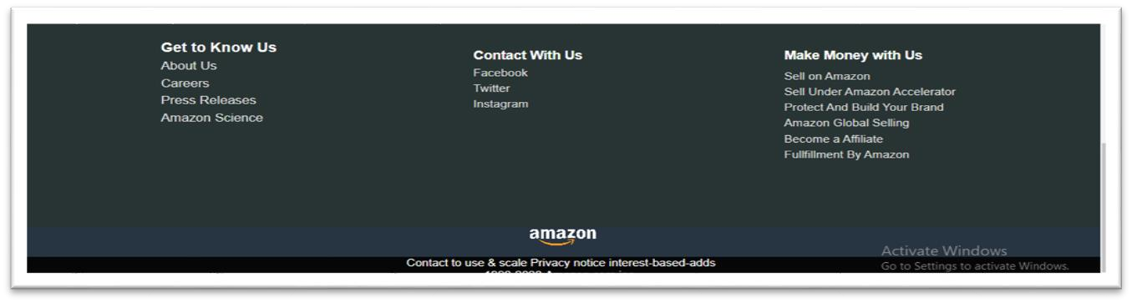

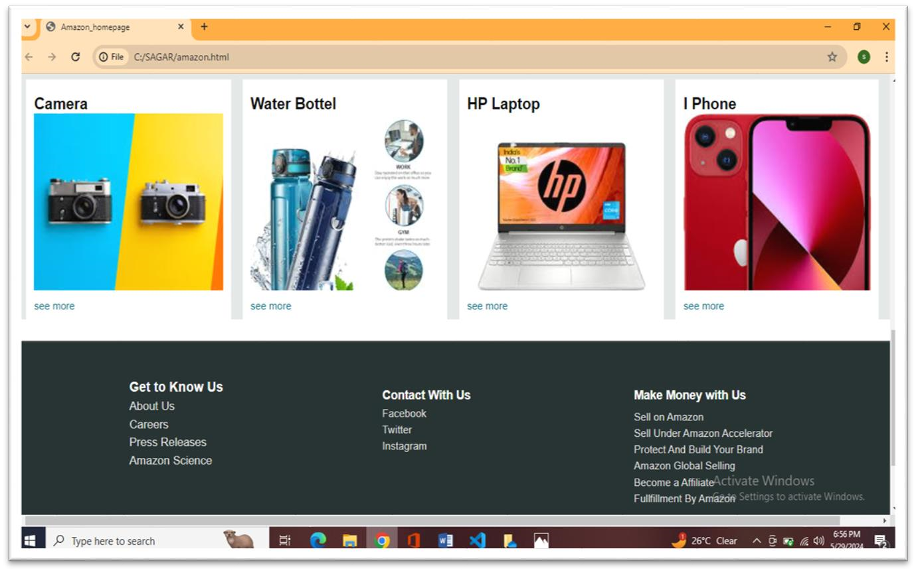

#### PROJECT USE CASES

1. **\*Project Overview\***

The Web Development project aims to develop a comprehensive e-commerce platform that replicates the core functionalities of Amazon.com. This includes user registration and authentication, product listings, search functionality, shopping cart, order management, payment processing, user reviews, and administrative capabilities.

1. **\*Actors\***

* *Visitor*: An unregistered user browsing the website.
* *Customer*: A registered user who can make purchases.
* *Seller*: A registered user who can list products for sale.
* *Administrator*: A user with elevated privileges to manage the website.

**3. *Functional Requirements\***

User Registration and Authentication

* *Sign Up*: Visitors can create an account using email and password.
* *Login*: Registered users can log in using their credentials.
* *Password Recovery*: Users can reset their password via email.

Product Listings

* *View Products*: Visitors and customers can browse product categories.
* *Product Details*: Users can view detailed information about a product including images, description, price, and reviews.
* *Search Products*: Users can search for products using keywords.
* *Filter Products*: Users can filter products based on categories, price range, brand, ratings, etc.

Shopping Cart

* *Add to Cart*: Customers can add products to their shopping cart.
* *View Cart*: Customers can view items in their cart.
* *Update Cart*: Customers can change quantities or remove items.
* *Checkout*: Customers can proceed to checkout to place an order.

Order Management

* *Place Order*: Customers can place orders after providing shipping details and payment information.
* *Order History*: Customers can view their past orders and order status.
* *Track Order*: Customers can track the shipping status of their orders.

Payment Processing

* *Payment Gateway Integration*: Secure integration with payment gateways like PayPal, Stripe, etc.
* *Transaction History*: Users can view their transaction history.

User Reviews and Ratings

* *Write Reviews*: Customers can write reviews and rate products.
* *View Reviews*: Customers can read reviews and ratings of products.

Seller Functionality

* *Product Management*: Sellers can add, edit, and delete their products.
* *Sales Reports*: Sellers can view their sales reports and performance metrics.

Administrative Capabilities

* *User Management*: Admins can manage user accounts, including suspending or deleting accounts.
* *Product Management*: Admins can manage all products listed on the platform.
* *Order Management*: Admins can manage all orders, including resolving disputes.
* *Analytics Dashboard*: Admins can view site analytics and reports.

**4. *Non-Functional Requirements\***

Performance

* The website should load within 3 seconds.
* The system should handle up to 10,000 concurrent users.

Security

* Secure user authentication and data protection.
* Compliance with data privacy laws (e.g., GDPR).

Usability

* Intuitive user interface for easy navigation.
* Mobile-responsive design.

Scalability

* The system should be scalable to accommodate future growth in user base and product listings.

**5. *Use Case Scenarios\***

User Registration and Login

* *Scenario*: A visitor signs up and logs into the website.
* *Preconditions*: Visitor is on the sign-up page.
* *Postconditions*: Visitor becomes a registered user and is logged in.

Product Search and Filter

* *Scenario*: A customer searches for a specific product and applies filters.
* *Preconditions*: Customer is on the homepage.
* *Postconditions*: Customer views the search results and filtered products.

Adding Items to Cart

* *Scenario*: A customer adds a product to their shopping cart.
* *Preconditions*: Customer is on the product detail page.
* *Postconditions*: Product is added to the customer’s cart.

Placing an Order

* *Scenario*: A customer proceeds to checkout and places an order.
* *Preconditions*: Customer has items in the cart.
* *Postconditions*: Order is placed, and the customer receives an order confirmation.

Writing a Review

* *Scenario*: A customer writes a review for a purchased product.
* *Preconditions*: Customer has purchased the product.
* *Postconditions*: Review is published and visible on the product detail page.

Managing Products (Seller)

* *Scenario*: A seller adds a new product to the platform.
* *Preconditions*: Seller is logged in.
* *Postconditions*: Product is listed on the platform.

Admin User Management

* *Scenario*: An admin suspends a user account.
* *Preconditions*: Admin is logged in and has the necessary privileges.
* *Postconditions*: User account is suspended.

**6. *User Interface Mockups\***

* Home Page: Features product categories, top deals, and a search bar.
* Product Detail Page: Displays product images, descriptions, price, reviews, and add-to-cart button.
* Shopping Cart: Lists items with options to update quantity or remove items.
* Checkout Page: Collects shipping information and payment details.
* Admin Dashboard: Provides tools for managing users, products, and orders.

#### CODE WITH DOCUMENTATION

**Web Development:**

<!DOCTYPE html>

<html lang="en">

<head>

<meta charset="UTF-8">

<meta http-equiv="X-UA-Compatible" content="IE=edge">

<meta name="viewport" content="width=device-width, initial-scale=1.0">

<title>Amazon homepage</title>

<link rel="stylesheet" href="https://cdnjs.cloudflare.com/ajax/libs/fontawesome/6.4.2/css/all.min.css" integrity="sha512-

z3gLpd7yknf1YoNbCzqRKc4qyor8gaKU1qmn+CShxbuBusANI9QpRohGBreCFkKxLhei6S9C QXFEbbKuqLg0DA=="

crossorigin="anonymous" referrer policy="no-referrer" />

<link rel="stylesheet" href="style.css">

</head>

<body>

<header>

**NAVBAR:**

<div class="navbar">

<p></p>

<div class="logo border">

</div>

<div class="nav-address border">

<p class="add-first">Deliver to</p>

<div class="add-icon">

<i class="fa-solid fa-location-dot"></i>

<p class="add-sec">India</p>

</div>

</div>

<div class="nav-search ">

<select class="search-select">

<option>All</option>

</select>

<input class="search-input" placeholder="Search amazon">

<div class="search-icon">

<i class="fa

-solid fa-magnifying-glass"></i>

</div>

</div>

<div class="nav-sign border">

<p><span>Hello, Sign in</span></p>

<p class="nav-sec">Account & Lists</p>

</div>

<div class="nav-return border">

<p><span>Returns, Sign in</span></p>

<p class="nav-sec">& Orders</p>

</div>

<div class="nav-cart border">

<i class="fa-solid fa-cart-shopping"></i>

Cart

</div>

</div>

**EXPLANATION:**

1. The code represents the structure of a navigation bar (<div class="navbar">) commonly used in web applications. This navigation bar likely belongs to an e-commerce website, possibly Amazon, given the placeholder text "Search amazon". A
2. Logo Section (<div class="logo border">):
3. This section presumably contains the logo of the website. However, there is no content provided within the <div>, so it's currently empty.
4. Delivery Address Section (<div class="nav-address border">):
5. This section displays the delivery address for the user.
6. It includes:
7. A paragraph (<p>) with the text "Deliver to".
8. An address icon (<i class="fa-solid fa-location-dot"></i>).
9. Another paragraph (<p>) containing the country name, likely "India".
10. Search Section (<div class="nav-search">):
11. This section allows users to search for items on the website.
12. It includes:
13. A dropdown menu (<select class="search-select">) for filtering search results.
14. An input field (<input class="search-input" placeholder="Search amazon">) where users can enter their search query.

**PANEL-OPTION**

<div class=" panel-opt">

<p class="a border">Today's Deals</p>

<p class="b border">Customer Service</p>

<p class="c border">Registry</p>

<p class="d border">Gift Cards</p>

<p class="e border">Sells</p>

<p class="f border">Mobiles</p>

<p class="g border">New Releases</p>

<p class="h border">Amazon Mini Tv</p>

</div>

<div class="shopping-sec">

<div class="box1 box">

<div class="box-content">

<h2>Cloths</h2>

<div class="box-img" style="background-image:url('box1_image.jpg');"></div>

<p>see more</p>

</div>

</div>

<div class="box2 box">

<div class="box-content">

<h2>Health & Personal Care</h2>

<div class="box-img" style="background-image:url('box2_image.jpg');"></div>

<p>see more</p>

</div>

**FOOTER**:

<footer>

<div class="foot-panel1">

</div>

<div class="customer-cont.">

<div class="about-us">

<h4 id="get ">Get to Know Us</h4>

<p id="details">About Us</p>

<p id="details">Careers</p>

<p id="details">Press Releases</p>

<p id="details">Amazon Science</p>

</div>

<div class="contact ">

<h4 id="con ">Contact with Us</h4>

<p id="details">Facebook</p>

<p id="details">Twitter</p>

<p id="details">Instagram</p>

</div>

<div class="money ">

<h4 id="mon">Make Money with Us</h4>

<p id="details">Sell on Amazon</p>

<p id="details">Sell Under Amazon Accelerator</p>

<p id="details">Protect and Build Your Brand</p>

<p id="details">Amazon Global Selling</p>

<p id="details">Become Affiliate</p>

<p id="details">Fulfillment By Amazon </p>

</div>

<div class="foot-panel3">

<div class="logo">

</div>

</div>

<div class="foot-panel4">

<p>Contact to use & scale Privacy notice interest-based-adds</p>

<div class="p5">

<P>1996-2023, Amazon.com,inc.</P>

</div>

</div>

</footer>

</header>

</body>

</html>

Balance

{ font-size:24px; marginbottom:20px

}

. transactions{ margin-top:

*20px*;

}

.container { width: *150px*; padding: *5px*; marginright:10px;

} button

{

Padding:*5px10*; cursor: pointer;

}

}

.container

{

Max-width:*400px*; margin:*0* auto; padding: *20px*; border:*1px* solid; border-radius: *5px*;

}

**DOCUMENTATION**

1. Back to Top Panel (<div class="foot-panel1">):

• This panel contains a link or button allowing users to quickly navigate back to the top of the webpage. The text "Back to Top" suggests its purpose.

2. Customer Content Section (<div class="customer-cont.">):

* This section provides various categories of information for customers to explore.
* It includes:
* About Us: Details about the company.
* Contact with Us: Links to social media platforms for contacting the company.
* Make Money with Us: Information on how individuals or businesses can make money through partnerships with Amazon.

3. Footer Panels:

* Panel 3 (<div class="foot-panel3">): Possibly intended for displaying a logo. Currently empty.
* Panel 4 (<div class="foot-panel4">):
* Contains legal and copyright information.
* It includes:
* Text regarding contacting the company, privacy notice, and interest-based ads.
* A sub-panel (<div class="p5">) containing the copyright notice, "1996-2023, Amazon.com, Inc."

#### CONCLUSION

In conclusion, my 4-week internship experience with TechnoHacks EduTech has been incredibly valuable in providing me with the necessary guidance and corporate exposure in the field of web development. Under the mentorship of Mr. Sandip Gavit, I gained practical skills, worked on realworld projects, and learned how to deploy and host my own projects.

Throughout the internship, I was able to apply the knowledge gained from coursework to solve real-world problems and develop websites that meet industry standards. The hands-on experience and exposure to different aspects of web development have greatly enhanced my understanding of the field and prepared me for future endeavors.

I am grateful for the opportunity provided by TechnoHacks EduTech and Mr. Sandip Gavit, and I look forward to applying the skills and knowledge acquired during this internship in my future career as a web developer.

#### REFERENCE

1. W3Schools: A comprehensive online resource for learning web development languages such as HTML, CSS, JavaScript, and more.
2. MDN Web Docs (Mozilla Developer Network): Provides detailed, documentation and tutorials on web technologies, including HTML, CSS, and JavaScript.

3.Stack Overflow: A popular question and answer platform where developers can seek help, share knowledge, and troubleshoot coding issues.

4.GitHub: A platform for version control and collaboration, where developers can access and contribute to open-source projects and repositories.

5.CSS-Tricks: A website offering tutorials, articles, and resources for CSS, including tips and tricks for creating modern web designs.

6.jQuery: A fast and feature-rich JavaScript library that simplifies HTML document traversing, event handling, and animation.